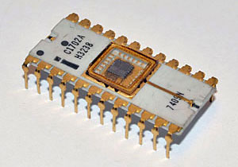**Software 32**

So…. Looking at the resulting MINOL ROM, it’s about 2,500 bytes or thereabouts in total.

Thinking in hardware terms, this isn’t good. I’m wasting 1/2k of ROM here – now, that isn’t much in 2016 terms, but in 1975 terms it is a heck of a lot.

So I have decided on some reorganisation.

Out from the monitor ROM go the Mathematics routines – which now aren’t used by anything – and into the monitor ROM goes the scrolling screen handler.

I’ve tweaked it a bit so there are vectors at 3 (Print Char/String) 5 (Get Char) 7 (Get String) and obviously changed MINOL so it calls these routines directly.

The monitor ROM now has two sets of screen drivers – the roll to the top and the scrolling version. It also has two keyboard input routines, but this isn’t really worth fixing.

There’s one problem ; I fixed up the integer printer so when it is left it sets P3 to the Print routine, so this can’t happen any more – the Print routine is elsewhere – so this is set up manually after the three calls to this routine.

It works quite nicely, and each ROM image (both 2 x 1k ROMs) has about 128 bytes of free program space, which is handy if there are any messy bugs.